

Cover Sheet for Report

Participants must complete this cover sheet to accompany each piece of coursework submitted. **No work will be marked without completion of this sheet.**

|  |  |  |  |
| --- | --- | --- | --- |
| Student Name: | Naveen Prakash | Student number: | F332159 |
| Submission Date: | 14/06/2024 | | |
| Programme Title: | Cyber security and Data Analytics | | |
| Module Title: | Game Technologies and Advanced 3D Environments | | |
| Assignment Title: |  | | |

If this coursework is part of a group activity, list the names of the other group members:

**Declaration**

By making this submission I confirm that the attached coursework is my own work and that anything taken from or based upon the work of others – or previous work of mine – has its source clearly and explicitly cited; I understand that failure to do so may constitute Academic Misconduct.

Game Technologies and Advanced 3D environments

**LLP120**

**I Critical analysis of game technologies [50 Marks]**

For this part, you can try to answer the following questions:

1. Choose an application of serious game and discuss its purpose.

*[Please note this question should not involve discussions pertaining to video games.]* ***(5 Marks)***

ii) Describe and critically analyze two different gaming technologies that are utilized in the application you have selected in part

***(i)****. You have to select two of the following gaming technologies: Physics Simulations, AI techniques for Gaming, 3D modelling, Rendering and Animation* ***(20 Marks)***

iii) Describe and critically analyze the 3D audio and video technologies, and how they can be used in the application you have selected in part

***(i)****. You may recognize the 3D audio and video technologies and how it is being used for increasing immersion in your selected game application* ***(25 Marks)***

**II The design of your own game using Unity [50 Marks]**

Your implementation should showcase the following skills: **(20 Marks)**

i) 3D modelling

ii) Terrain creation

iii) Player movement

iv) Physics simulation

v) Animation

You should also include the following sections: **(30 Marks)**

Implementation aligning to the above skills. Describe in general the steps you took to create your game. Include which tools you used in Unity and what this added to your game. You may include screenshots where necessary.

Further improvements that could be made. Describe any challenges you faced and features you would like to add in the future and which technologies you could use to create them.

A YouTube link to footage of your game being played

**I Critical analysis of game technologies:**

1. Selected application of a serious game: **Flight simulation.**
2. Selected gaming technologies: **Physics simulation** and **AI techniques for gaming**.
3. Application of 3D audio and video technologies in **Flight simulation.**

**Introduction:**

A serious game is a type of video game that doesn’t emphasize the entertainment aspect of traditional video games. These games are typically used education, training and simulation. They act as a middle ground between the engagement aspect of a video game and education. The serious games today range from surgery simulation, Interior Design, universe’s events simulators, and finally flight simulation. Flight simulation will be the focus for this essay because, the aviation industry relies heavily on flight simulation. Flight simulators are designed meticulously to train pilots and other aviation professionals in a hyper-realistic virtual environment. These simulators replicate various aspects of flying, including aircraft controls, flight dynamics, and different weather conditions(Allerton, 2010). Some of the famous flight simulators in the market now are, Microsoft Flight Simulator(Microsoft, 2019), X-plane 12(Buy It - X-Plane, 2016), and DCS World(Digital Combat Simulator, 2019).

These simulators provide, skill development where Pilots can practice flying techniques, navigation, and emergency procedures without risking lives or aircraft. This ensures that they are well-prepared for actual flights. They also provide a degree of familiarization where the trainees will become familiar with the different types of planes, their cockpit layout, instrumentation, and operational behavior of different aircraft since these are crucial for transitioning to new types of aircrafts. Flight simulators are also very cost efficient. They provide a cost-effective means of training, reducing the need for actual flight hours, which are expensive and resource-intensive.

Flight simulators are used extensively by commercial airlines, military organizations, and flight schools. They are an essential tool in pilot training programs, helping to ensure safety and proficiency in aviation operations.

The rest of this essay will go on to explain about the gaming technologies in flight simulators and 3D audio and video technologies as well. It will also critically analyze the purpose and uses of these technologies in flight simulators.

**Gaming Technologies in Flight Simulators:**

**1. Physics Simulations:**

Physics simulations are the foundation for creating realistic movement and interactions within a game world. They involve applying the principles of physics (gravity, inertia, collision detection) to virtual objects and characters(Holzkorn, 2008). The aim is to create realistic behavior for objects within a game environment. This is achieved by applying the principles of physics (forces, motion, gravity, etc.) to virtual objects. Some of the core concepts include forces and motion, material properties where different materials like, wood, metal and cloth have distinct properties like elasticity and weight, which are factored into the simulation for realistic behavior, and finally Collision Detection, where the simulation identifies when objects come into contact and determines the resulting effects like bouncing, breaking, etc.

Physics simulations in flight simulators replicate the physical behaviors of aircraft, including aerodynamics, engine performance, and environmental effects such as wind, turbulence, and gravity. These simulations are designed to mimic the real-world physics that govern aircraft flight.

The Accuracy of physics simulations are crucial for effective pilot training (Holzkorn, 2008). They ensure that the flight dynamics and aircraft responses are realistic, providing trainees with an authentic flying experience. High-fidelity simulations capture the nuances of aircraft behavior, such as how different control inputs affect the aircraft's pitch, roll, and yaw.

The task of constructing physically accurate simulations are proven to be very multifaceted and complex, requiring detailed modeling of various aerodynamic and mechanical factors. This includes understanding the interplay between lift, drag, thrust, and weight. The complexity increases with the need to simulate different aircraft models and conditions accurately.

It has also been noted that the real-time feedback from physics simulations helps trainees understand the impact of their inputs and decisions, facilitating better learning and skill development. For example, if a pilot makes an incorrect control input, the simulator will respond as a real aircraft would, allowing the pilot to learn from the experience.

In conclusion, the construction of physics simulation are proven to be complex but when done, they are essential for creating a realistic training environment. They provide the foundation for other aspects of the simulator, such as visual and auditory feedback. The accuracy of these simulations directly impacts the quality of the training.

**2. AI Techniques for Gaming:**

The realm of video games has witnessed a continuous evolution, not just in terms of graphics and processing power, but also in the sophistication of the artificial intelligence (AI) that governs the behavior of non-player characters (NPCs), virtual worlds, and even gameplay mechanics. Some of the core techniques are, Decision making and machine learning. Decision making equips NPCs with the ability to make informed decisions based on the game environment, player actions, and their programmed goals. This can involve choosing attack strategies in combat scenarios, reacting to unexpected situations, or even engaging in social interactions within a virtual world. Decision-making algorithms often utilize techniques like finite state machines (FSMs) (Selvi et al., 2024), where characters transition between pre-defined states based on specific triggers. The incorporation of machine learning algorithms represents a significant advancement in AI for gaming. ML allows NPCs to learn and adapt their behavior based on experience and player interaction. For instance, an enemy AI might learn from the player's tactics and adjust its attack patterns accordingly. Similarly, ML can be used to personalize the difficulty level by tailoring the AI's behavior to the player's skill level.

There are various AI techniques in flight simulators that are used to create intelligent, responsive environments. AI can simulate air traffic control (ATC), other aircraft, and changing weather conditions, providing a dynamic and interactive training experience.

The AI in flight simulators can adjust scenarios based on the trainee's performance, providing a personalized and challenging training experience. For example, if a trainee performs well in a basic scenario, the AI can introduce more complex challenges, such as navigating through heavy traffic or dealing with unexpected weather changes.

AI-driven elements can also enhance realism by replicating the behavior of other aircraft, ATC communications, and unpredictable factors like bird strikes or equipment failures(Goecks et al., 2022). This creates a more immersive and realistic training environment, helping pilots prepare for the complexities of real-world flying. This in-turn, also increases the effectiveness of training by allowing a wide range of training scenarios, preparing pilots for diverse situations they may encounter. This comprehensive training leads to better preparedness and decision-making skills. Pilots can practice communication with ATC, coordination with other aircraft, and responding to dynamic changes in the environment.

In conclusion, AI techniques are crucial for creating a dynamic and engaging training environment. They allow for a wide range of scenarios and interactions, making the training more comprehensive and realistic. However, like all AI models, the effectiveness of AI-driven simulations depends on the quality of the data and the accuracy of the algorithms used.

**iii) 3D Audio and Video Technologies in Flight Simulators**

**3D Audio Technologies:**

3D Audio technology aims to replicate the natural way we perceive sound in the real world, where noises originate from distinct locations and travel to our ears with subtle variations based on distance, direction, and reflection(Cengarle, 2024). This technology leverages multiple speakers or headphones to manipulate sound source locations within a three-dimensional space. This allows listeners to perceive sounds originating from above, below, and around them, mimicking natural sound perception and enhancing the feeling of presence within the auditory environment. 3D audio has applications in various fields, including virtual reality, gaming, film production, and live performances, fostering a heightened sense of engagement and realism for the audience.

3D audio technology in flight simulators creates a spatial sound environment which allows trainees to perceive audio cues from different directions and distances as they would in a real cockpit. This includes the sounds of the aircraft engines, ATC communications, and environmental sounds such as wind and rain.

3D audio in flight simulation enhances immersion by replicating the sounds of the cockpit, engine noises, ATC communications, and environmental sounds. This realistic audio environment helps trainees to feel more present and engaged in the simulation. For example, the sound of an engine running rough or an alarm going off can indicate a potential issue that needs attention. This also helps the trainee to master situational awareness. Accurate spatial audio aids in developing situational awareness. For instance, the direction and urgency of an alarm can indicate the severity and location of an issue, prompting appropriate responses from the pilot. This is crucial for maintaining safety and making quick, informed decisions.

Realistic audio can simulate the high-stress environment of actual flight operations, helping trainees practice maintaining composure and effectiveness under pressure. This is particularly important for emergency scenarios, where clear communication and quick decision-making are vital.

In conclusion, 3D audio technology plays a significant role in creating a realistic and immersive training experience. It helps trainees to develop the situational awareness and decision-making skills necessary for real-world flying. The quality of the audio simulation can significantly impact the effectiveness of the training.

**3D Video Technologies:**

The purpose of 3D video technologies is to replicate the depth perception and spatial relationships we encounter in the real world. This is achieved by capturing or generating two slightly different video streams, one for each eye, mimicking the way our eyes perceive depth(Matsuyama et al., 2012). This is achieved by capturing or generating two slightly offset views, mimicking the way our eyes perceive the world. When presented on a compatible display or through the use of specialized glasses, these views combine to create a stereoscopic effect, allowing viewers to experience a sense of depth and volume within the video content. 3D video has the potential to revolutionize various fields, from entertainment and education to scientific visualization and medical training, by offering a more immersive and engaging experience compared to traditional two-dimensional video.

For flight simulation, it involves creating three-dimensional visual representations of the flight environment, including the cockpit, aircraft exterior, and surrounding scenery, providing depth perception and a realistic view of flying.

3D video allows for detailed visualization of the cockpit layout, controls, and instruments. Trainees can see the spatial relationships and interact with the virtual environment as they would in a real aircraft. This is crucial for tasks such as instrument scanning and identifying controls quickly and accurately. Combining 3D video with interactive elements, such as virtual reality (VR), enables hands-on practice. Trainees can manipulate controls, navigate through airspace, and perform flight maneuvers, enhancing their operational proficiency. For example, pilots can practice procedures such as takeoff, landing, and emergency maneuvers in a safe, controlled environment.

3D video technology significantly increases immersion, making the training experience more lifelike and engaging. This realism can lead to better retention of knowledge and skills, as trainees are more likely to remember and apply what they have learned. The ability to interact with the environment and see realistic visuals helps reinforce learning.

**Conclusion**

Flight simulators, utilizing physics simulations and AI techniques, provide a comprehensive and effective training tool for aviation professionals. These technologies create a realistic and immersive training environment, helping pilots develop the skills and knowledge necessary for safe and proficient flying. The integration of 3D audio and video technologies further enhances the realism and immersion of these simulators, leading to improved training outcomes and better preparedness for real-world flight operations.

As technology continues to advance, flight simulators will become even more realistic and accessible, further enhancing their effectiveness as training tools. This will lead to improved safety and efficiency in aviation operations, benefiting both pilots and the broader aviation industry.

**References:**

Allerton, D.J. (2010) ‘The impact of flight simulation in aerospace’, *The Aeronautical Journal*, 114(1162), pp. 747–756. Available at: <https://doi.org/10.1017/s0001924000004231>.

Microsoft (2019) Microsoft Flight Simulator, Microsoft Flight Simulator. Available at: <https://www.flightsimulator.com/>.

Buy It - X-Plane (2016) www.x-plane.com. Available at: <https://www.x-plane.com/desktop/buy-it/>.

Digital Combat Simulator (2019) Digitalcombatsimulator.com. Available at: <https://www.digitalcombatsimulator.com/en/>.

Holzkorn, P. (2008) Physics Simulation in Games. Available at: <http://holzkorn.com/assets/psig.pdf>.

Selvi, V.T. et al. (2024) ‘Extending the FSM Model for Critical Decision-Making and Safety Control in Autonomous Vehicles’, International Journal of Intelligent Systems and Applications in Engineering, 12(2s), pp. 397–410. Available at: https://ijisae.org/index.php/IJISAE/article/view/3640 (Accessed: 14 June 2024).

Goecks, V.G. et al. (2022) ‘On games and simulators as a platform for development of artificial intelligence for command and control’, The Journal of Defense Modeling and Simulation: Applications, Methodology, Technology, p. 154851292210832. Available at: <https://doi.org/10.1177/15485129221083278>.

Cengarle, G. (2024) ‘3D audio technologies : applications to sound capture, post-production and listener perception’, Tdx.cat [Preprint]. Available at: <http://hdl.handle.net/10803/101415>.

Matsuyama, T. et al. (2012) 3D Video and Its Applications, Google Books. Springer Science & Business Media. Available at: https://books.google.co.uk/books?hl=en&lr=&id=gD6xDtHZ5hUC&oi=fnd&pg=PR4&dq=3D+video+technology&ots=9YiCKCyU5-&sig=Bxw3zHt4leQicSPp3QqXkFVeKgo#v=onepage&q=3D%20video%20technology&f=false (Accessed: 14 June 2024).

**II) The design of your own game using Unity**

**Executive summary:**

This report is written for the purpose of reporting on a coursework in the module Game Technologies and advanced 3D environments. The task was to make a game in unity with certain features and also to include a 3D model made in blender into your game. The idea was to create a survival game, where the player will be chased by an enemy and the objective is to not let him kill you. Various scripts and assets were used in the making of this game. This report will delve deeper into this in the methodologies section.

**Introduction:**

Unity serves as a real-time development platform, excelling in the construction of interactive experiences like video games. It empowers users to leverage a comprehensive suite of tools for building environments, scripting functionalities, and integrating various multimedia assets. Conversely, Blender operates as a free and open-source 3D creation suite. Its strengths lie in modeling, sculpting, texturing, and animation, enabling the creation of high-quality 3D assets for games, movies, and other visual media applications. While distinct in their primary focus, Unity and Blender can be employed collaboratively within a development pipeline. 3D assets crafted in Blender can be imported and integrated into the projects built within the Unity engine.

Using these two platforms, a game was developed with the required features, 3D modelling, Terrain creation, Player movement, Physics simulation, and Animation. The next section will elaborate further on the development process of this game.

**Methodology:**

This section will first elaborate on how the required features were implemented into the game and finally explains how the game engine.

**3D modelling:**

In this game I’ve only modelled one 3D model and that’s a decorative asset that has been imported into the game. The 3D model is a boat. It was made in blender by slicing a sphere mesh in halfand adjusting the vertices in order to shape like a boat. Later two cubes, two cylinders, and two toruses were included where the cylinders and the toruses were placed strategically to act as a handle for oars, the two cubes were transformed to shape like a seat inside the boat *(look into figure 1. for reference).*This model was then exported as a .fbx file and imported into unity.

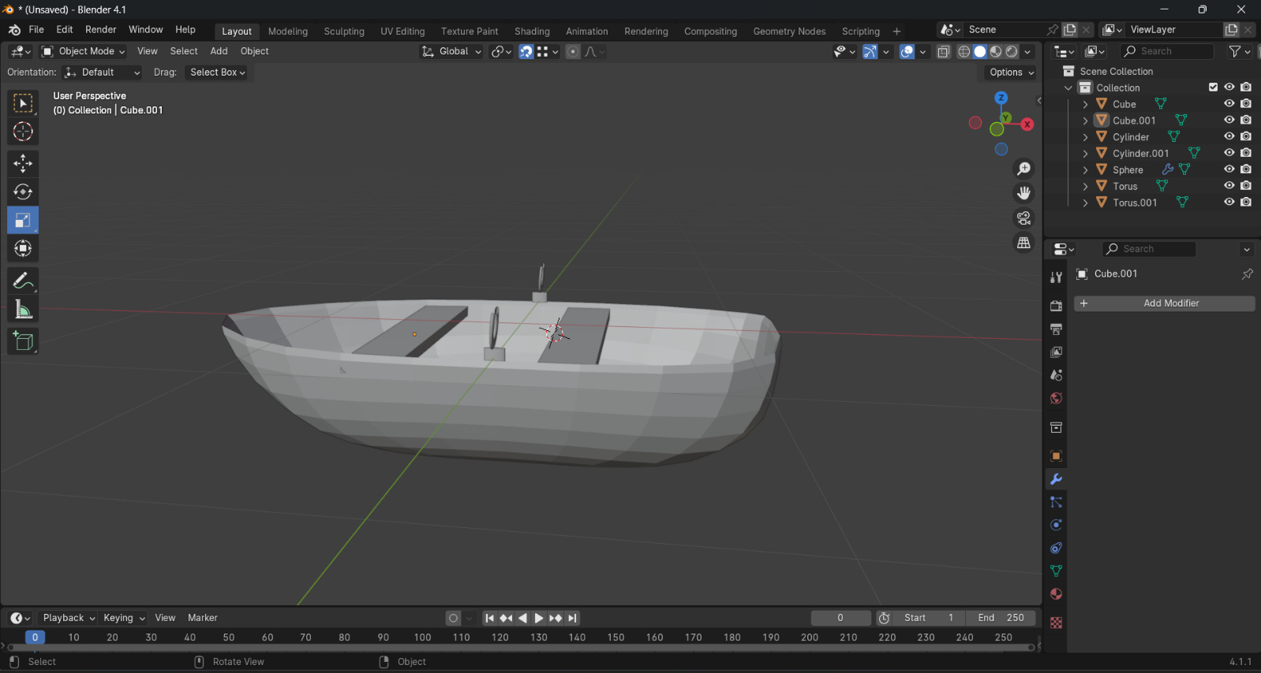

**Figure 1 the boat in blender**

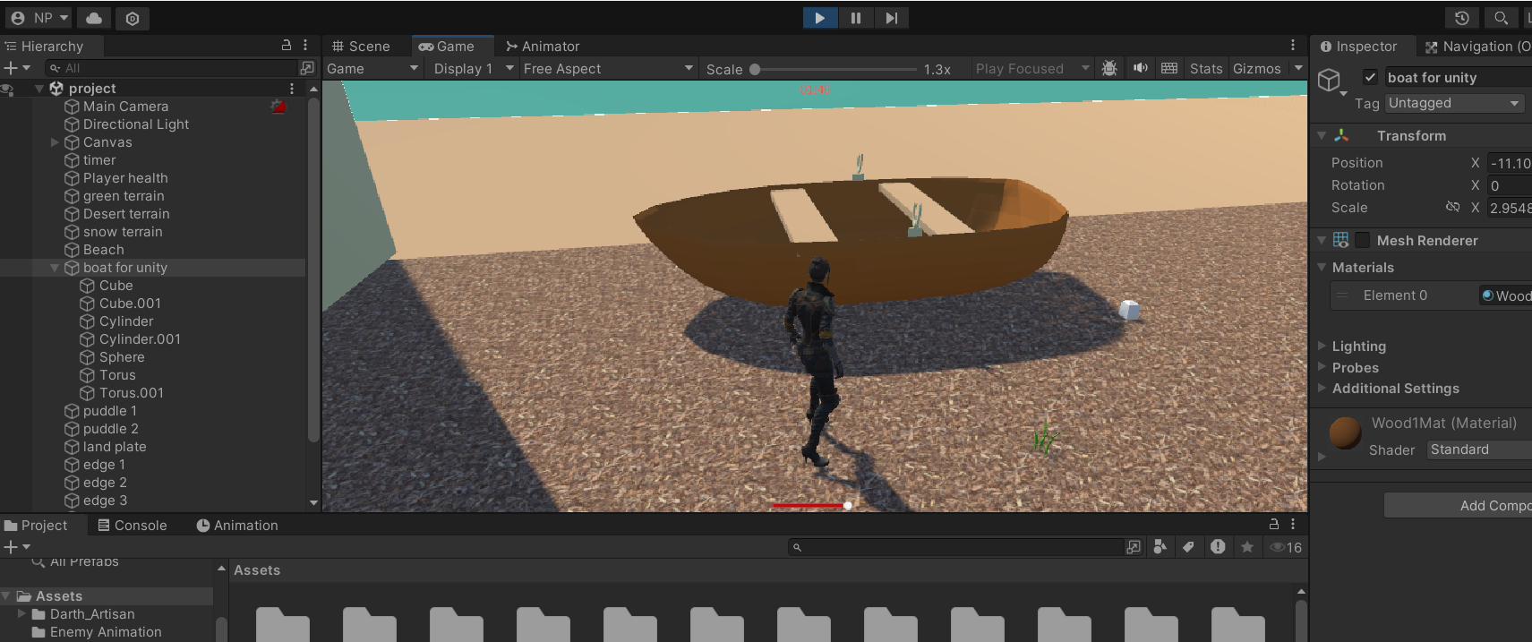

Figure 1.2 The boat in unity

**Terrain Creation:**

The terrain in this game is really massive. There are 5 terrains namely, green terrain, desert terrain, snow terrain, beach terrain and finally land plate which is a terrain underneath these four terrains. The land plate was made to resemble the sandy shores in beaches. I’ve also added water surrounding the map to increase immersion.

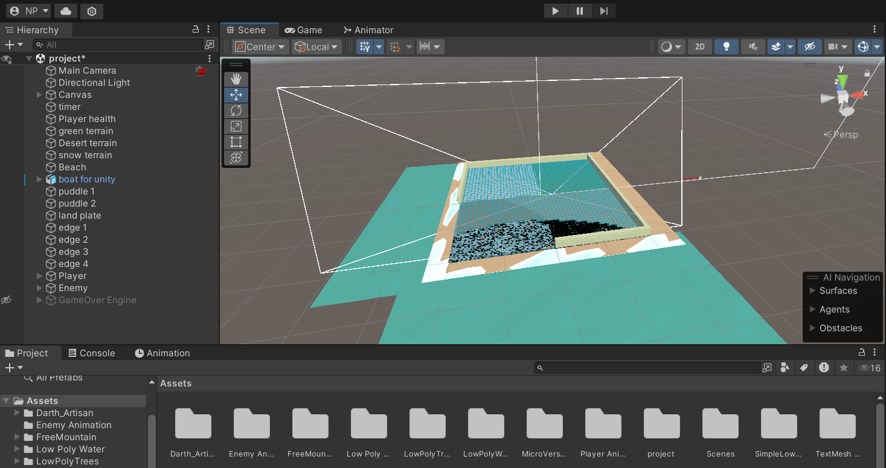

Figure 2 The whole map

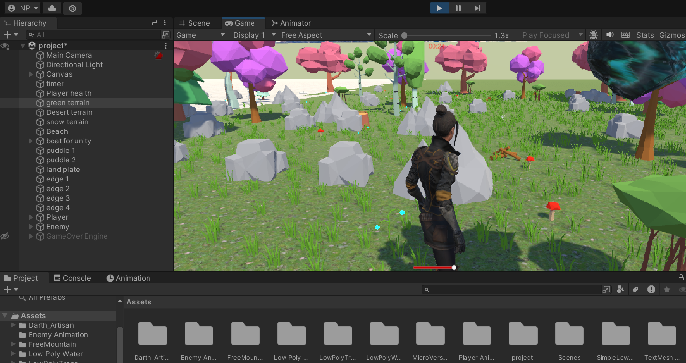

Figure 2.1 Green Terrain

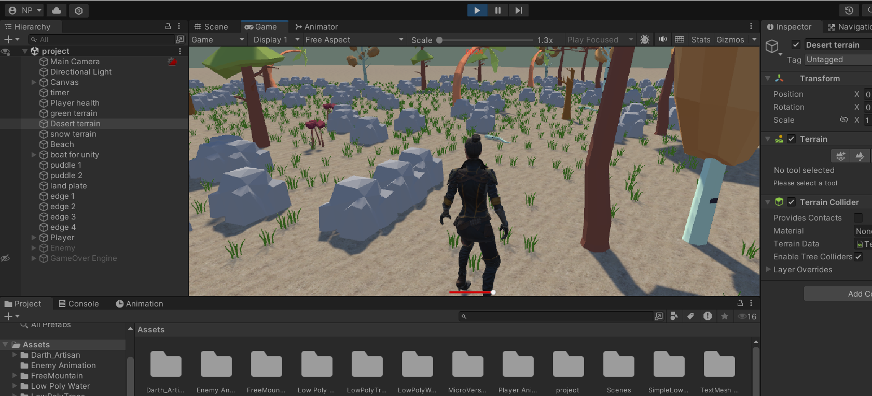

Figure 2.3 Desert Terrain

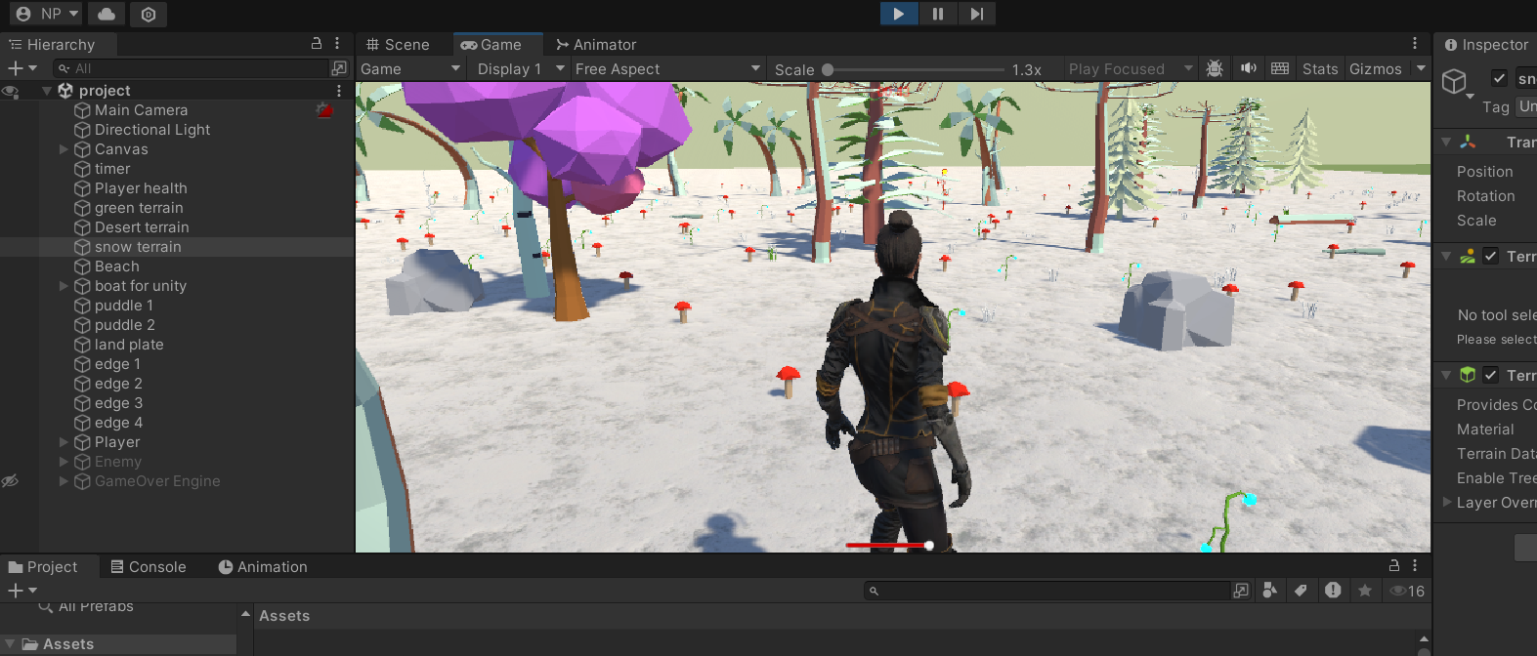Figure 2.4 Snow terrain

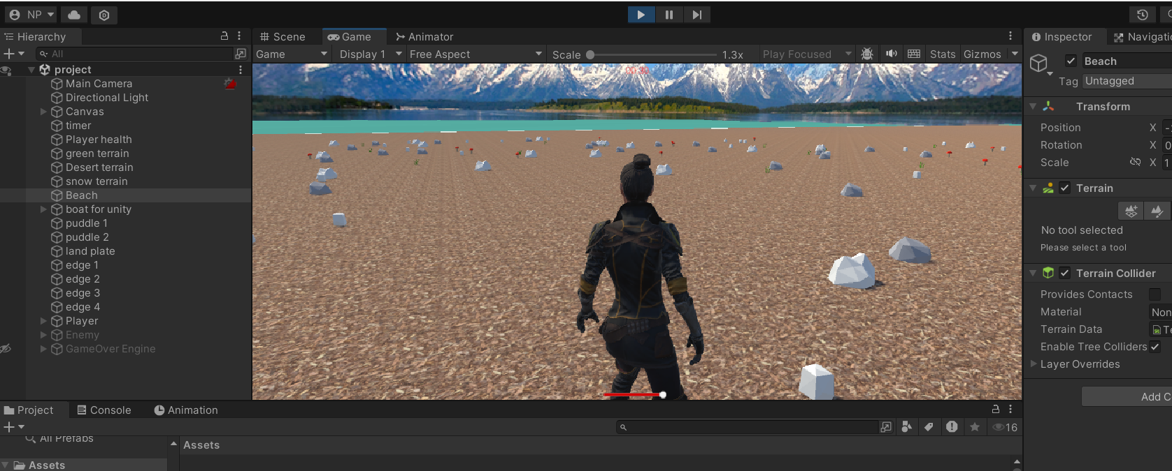

Figure 2.5 Beach Terrain

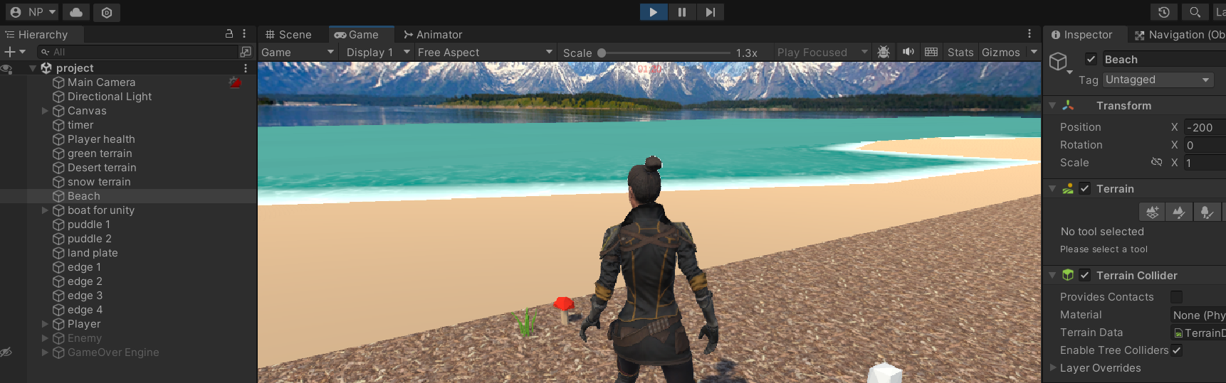Figure 2.6 Land plate (sandy shores)

The trees and other objects (except the boat) in the terrains were acquired from the unity asset store.

**Player Movement:**

There are two character objects in this game, a player and an enemy. Since the enemy chases the player, there is a need to give movement to the enemy as well. Firstly, The character model for both player and the enemy was acquired from [mixamo.com](http://www.mixamo.com).

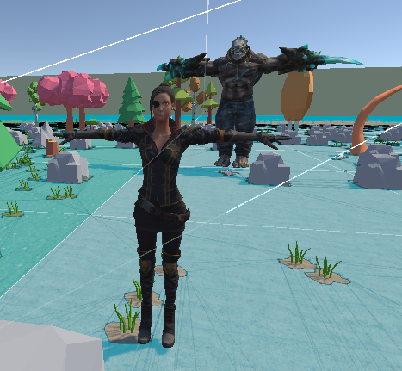

Figure 3 The player and enemy model.

To move a 3rd person character model, two components are necessary. A script to actually move them through the terrain and triggering animations. For the player model a basic horizontal and vertical script was effective enough. But for the enemy model the logic is different since it is an AI, there is an another component called nav-mesh agent. We use nav-mesh agent to bake the areas you want the enemy model to move around in. And on top of that we can make a script for it to target an object in the terrain to chase. The screenshots of the scripts are as follows,

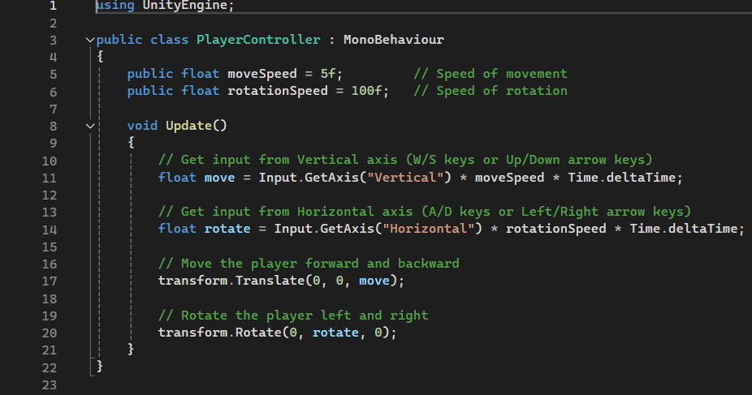

Figure 3.1 Player Movement script

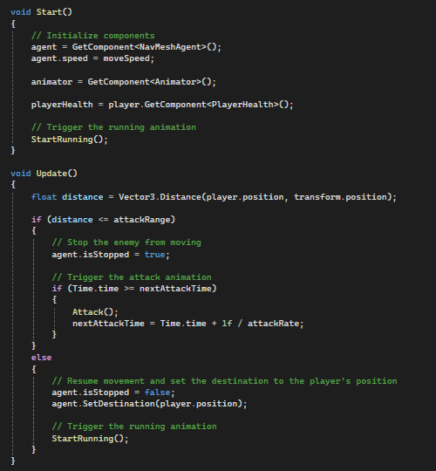

Figure 3.2 Enemy model movement

**Physics Simulation:**

The game physics is basically, the player is assigned with 200 health. The enemy will chase and attack him. When the enemy attacks, the player’s health reduced by 10. The health bar is at the bottom of the screen while the timer runs on the top. The health bar is a slider, so whenever the enemy model attacks the player, the slider moves towards the left indicating the deduction in health. This action of enemy attacking goes in the enemy AI movement script where the logic is the enemy targets the player object moves near it and attacks it. The player object also has a health script attached with the slider UI. The following screenshots prove the enemy attacks and health deductions. Will also include the screenshots of the scripts.

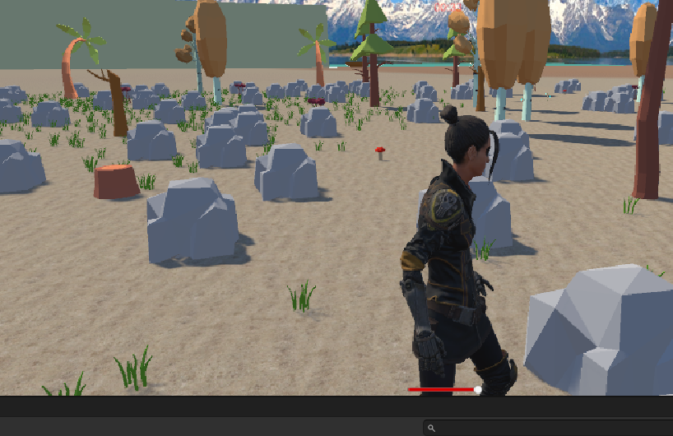

Figure 4 health bar before enemy attacks

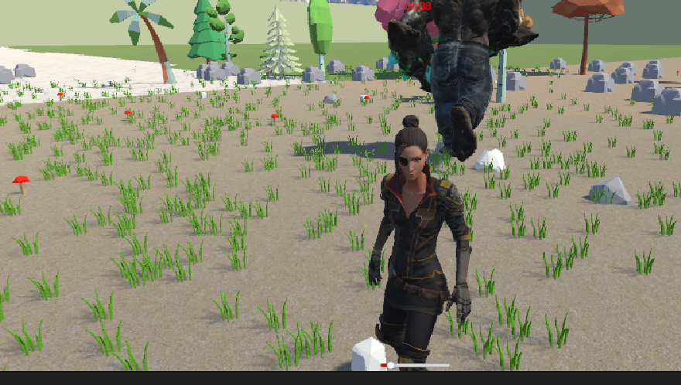

Figure 4.1 health bar after enemy attacks

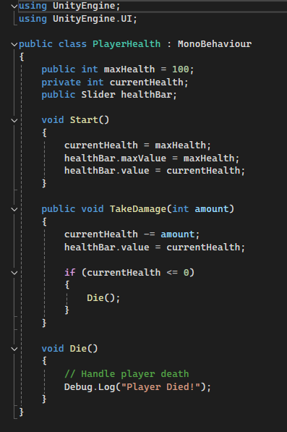

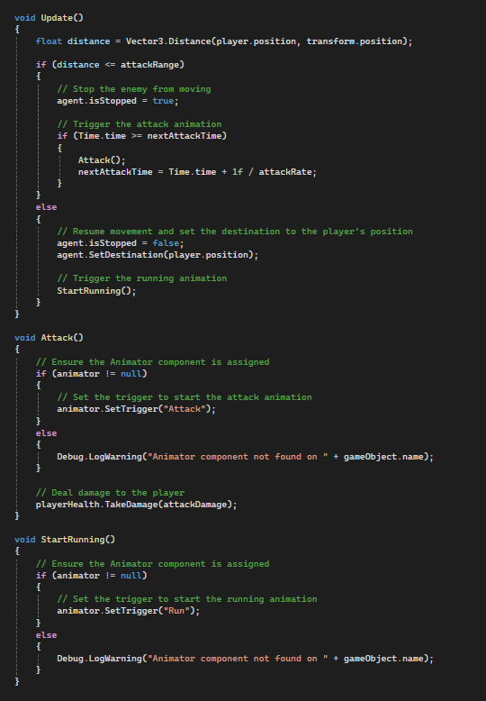

Figure 4.3 Enemy attacks script

**Animation:**

The animation component here is used only for the running animations of both the player and enemy models. As a bonus there is a jump animation on the player model. This was done by using the animator component and a script to trigger these animations. The keyframe animation clip is selected and put in the animator tab. There various triggers were initiated such as, run, jump run backwards, etc.. Then the triggers were given transitions with other respective animations. For the player there are four states, Idle, jog, jog back, jump. And for the enemy its run, attack.

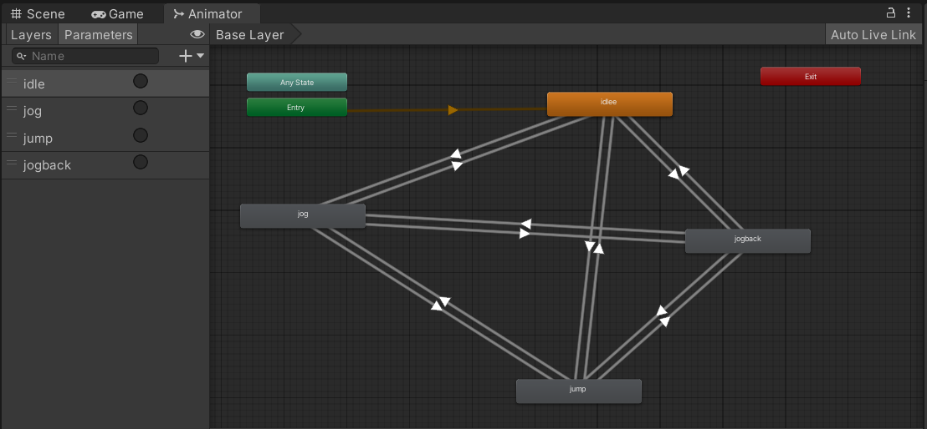

Figure 5.0 player’s animation triggers

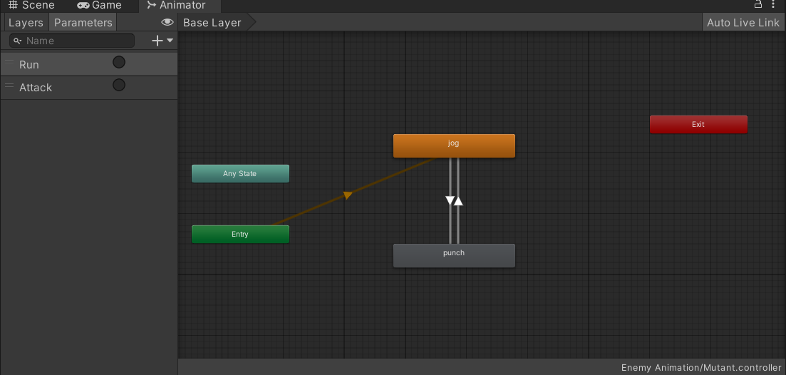

Figure 5.1 Enemy’s Animation Triggers

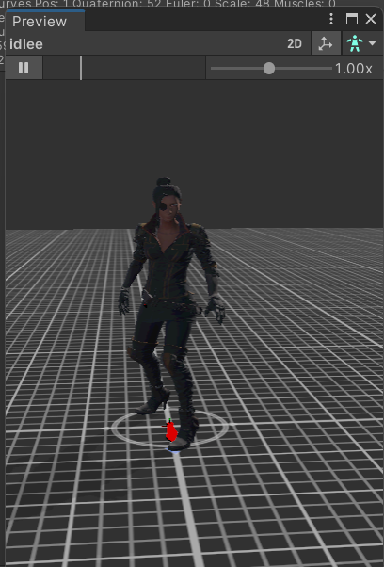

Figure 5.2 Player’s Idle Animation

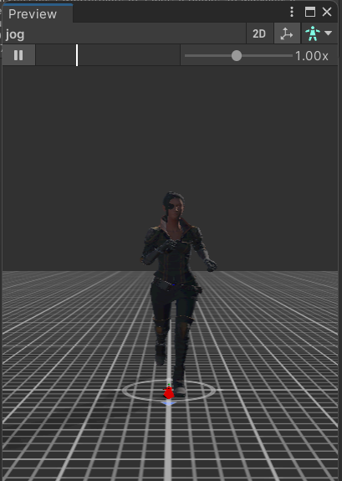

Figure 5.3 Player’s running animation

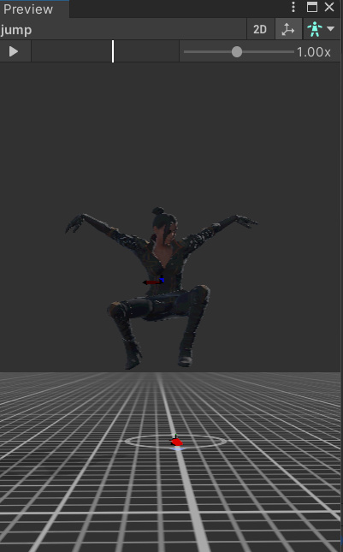

Figure 5.4 player jumping animation

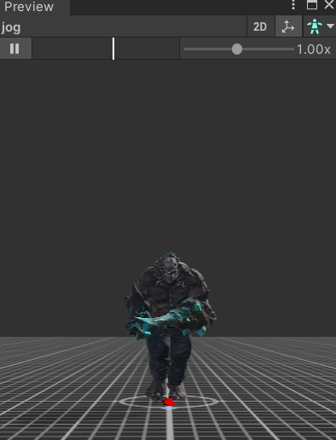

Figure 5.5 enemy running

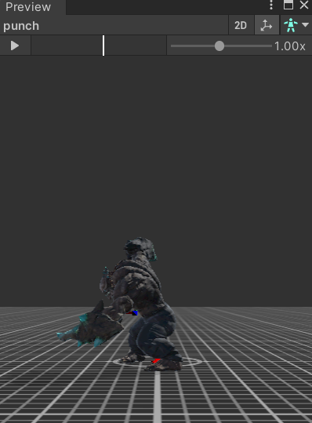

Figure 5.6 enemy attacking

**Conclusion & future works:**

Of all the features, terrain creation was a challenge to make and very time consuming. The game in its state right now is really easy and there is no stakes in it. So for future works, the idea is after the player survives 2 minutes in the game an extra enemy is spawned and this will go on forever. This will give a sort of stakes to this game and have the player really engaged.

**The YouTube Video Link :** <https://youtu.be/15l-uoCY4_I>